Graph

What is a Graph?
# Source: AI Source: Provided by: [Data Path: Persons Table -> ID Column: 1, Name_En Column: Motasem Essam] -> From: [Chatgpt (GPT‑5 Mini)] on [12/10/2025]
- A Graph is a non-linear data structure consisting of nodes (vertices) and edges connecting them.
- Used to represent relationships, networks, and connections.
- Types of graphs include directed, undirected, weighted, unweighted, and cyclic/acyclic.

Key Characteristics
# Source: AI Source: Provided by: [Data Path: Persons Table -> ID Column: 1, Name_En Column: Motasem Essam] -> From: [Chatgpt (GPT‑5 Mini)] on [12/10/2025]
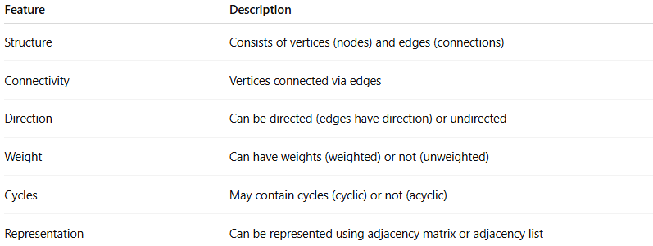
Feature | Description
Structure | Consists of vertices (nodes) and edges (connections)
Connectivity | Vertices connected via edges
Direction | Can be directed (edges have direction) or undirected
Weight | Can have weights (weighted) or not (unweighted)
Cycles | May contain cycles (cyclic) or not (acyclic)
Representation | Can be represented using adjacency matrix or adjacency list

Types of Graphs
# Source: AI Source: Provided by: [Data Path: Persons Table -> ID Column: 1, Name_En Column: Motasem Essam] -> From: [Chatgpt (GPT‑5 Mini)] on [12/10/2025]
- Undirected Graph
  - Edges have no direction.
  - Connection is bidirectional.
  - Example: Friendship networks.
- Directed Graph (Digraph)
  - Edges have a direction from one vertex to another.
  - Example: Twitter follow system.
- Weighted Graph
  - Edges have weights representing cost, distance, or time.
  - Example: Road network with distances between cities.
- Unweighted Graph
  - All edges have equal weight or no weight.
  - Example: Simple connections between nodes.
- Cyclic Graph
  - Contains at least one cycle.
- Acyclic Graph
  - Contains no cycles.
- Connected Graph
  - There is a path between every pair of vertices.
- Disconnected Graph
  - At least one pair of vertices has no path connecting them.

Graph Representations
# Source: AI Source: Provided by: [Data Path: Persons Table -> ID Column: 1, Name_En Column: Motasem Essam] -> From: [Chatgpt (GPT‑5 Mini)] on [12/10/2025]
- Adjacency Matrix
  - 2D array to represent connections between vertices.
  - Entry matrix[i][j] = 1 if there is an edge from vertex i to j.
- Adjacency List
  - Each vertex stores a list of adjacent vertices.
  - Efficient for sparse graphs.
Example:
Vertices: 0, 1, 2, 3
Edges: (0-1), (0-2), (1-2), (2-3)
- Adjacency Matrix:
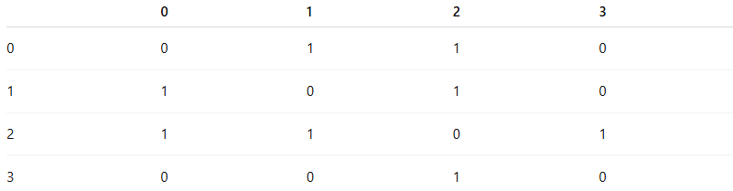
 | 0 | 1 | 2 | 3
0 | 0 | 1 | 1 | 0
1 | 1 | 0 | 1 | 0
2 | 1 | 1 | 0 | 1
3 | 0 | 0 | 1 | 0
- Adjacency List:
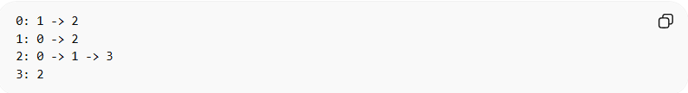
0: 1 -> 2
1: 0 -> 2
2: 0 -> 1 -> 3
3: 2

Common Operations on Graph

1. Insertion (Adding a Vertex/Edge)
# Source: AI Source: Provided by: [Data Path: Persons Table -> ID Column: 1, Name_En Column: Motasem Essam] -> From: [Chatgpt (GPT‑5 Mini)] on [12/10/2025]
Definition:
- Insertion adds a new vertex or edge to the graph.
- Adding a vertex involves creating a new node in the adjacency list or expanding the adjacency matrix.
- Adding an edge involves connecting two vertices by updating adjacency structures.
Example (Adjacency List):
Vertices: 0, 1, 2
Add vertex 3 and edge (2,3):
Adjacency List Before:
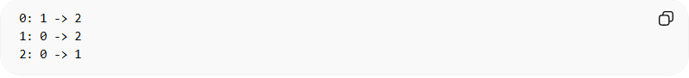
0: 1 -> 2
1: 0 -> 2
2: 0 -> 1
Adjacency List After:
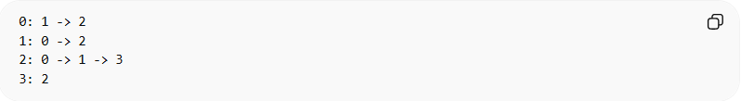
0: 1 -> 2
1: 0 -> 2
2: 0 -> 1 -> 3
3: 2
Insertion Time Complexity:
- Vertex: O(1)
- Edge: O(1) (adjacency list), O(1) (adjacency matrix)
Reason: Adding involves updating pointers or matrix entries without traversal.

2. Deletion (Removing a Vertex/Edge)
# Source: AI Source: Provided by: [Data Path: Persons Table -> ID Column: 1, Name_En Column: Motasem Essam] -> From: [Chatgpt (GPT‑5 Mini)] on [12/10/2025]
Definition:
- Deletion removes a vertex or an edge from the graph.
- Removing a vertex requires deleting all connected edges.
- Removing an edge requires updating adjacency structures to remove the connection.
Example (Remove Edge 2-3):
Before:
2: 0 -> 1 -> 3
3: 2
After:
2: 0 -> 1
3:
Deletion Time Complexity:
- Time Complexity
  - Vertex: O(V + E) for adjacency list, O(V²) for adjacency matrix
  - Edge: O(V) for adjacency list, O(1) for adjacency matrix
- Reason: Must update adjacency information for connected vertices.

3. Traversal (Visiting All Nodes)
# Source: AI Source: Provided by: [Data Path: Persons Table -> ID Column: 1, Name_En Column: Motasem Essam] -> From: [Chatgpt (GPT‑5 Mini)] on [12/10/2025]
Definition:
- Traversal means visiting all vertices in the graph in a specific order.
- Used to explore, search, or process graph data.
Types of Traversal:
- Breadth-First Search (BFS)
  - Visit nodes level by level, starting from a source vertex.
  - Uses a queue.
  - Example traversal sequence (start at vertex 0): 0 → 1 → 2 → 3
  - Example in C (queue-based BFS):
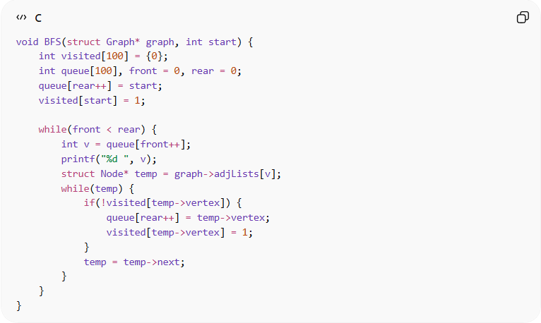
void BFS(struct Graph* graph, int start) {
int visited[100] = {0};
int queue[100], front = 0, rear = 0;
queue[rear++] = start;
visited[start] = 1;

while(front < rear) {
int v = queue[front++];
printf("%d ", v);
struct Node* temp = graph->adjLists[v];
while(temp) {
if(!visited[temp->vertex]) {
queue[rear++] = temp->vertex;
visited[temp->vertex] = 1;
}
temp = temp->next;
}
}
}
Traversal - Breadth-First Search (BFS) Time Complexity:
  - Time Complexity: O(V + E)
  - Reason: Each vertex and edge is visited once.
- Depth-First Search (DFS)
  - Visit nodes depth-first, exploring as far as possible before backtracking.
  - Uses a stack or recursion.
  - Example traversal sequence (start at vertex 0): 0 → 1 → 2 → 3
  - Example in C (recursive DFS):
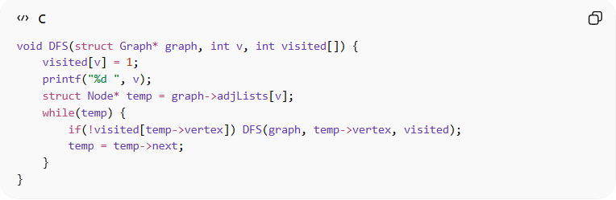
void DFS(struct Graph* graph, int v, int visited[]) {
visited[v] = 1;
printf("%d ", v);
struct Node* temp = graph->adjLists[v];
while(temp) {
if(!visited[temp->vertex]) DFS(graph, temp->vertex, visited);
temp = temp->next;
}
}
Traversal - Depth-First Search (DFS) Time Complexity:
  - Time Complexity: O(V + E)
  - Reason: Each vertex and edge is visited once.

4. Searching (Finding a Vertex/Edge)
# Source: AI Source: Provided by: [Data Path: Persons Table -> ID Column: 1, Name_En Column: Motasem Essam] -> From: [Chatgpt (GPT‑5 Mini)] on [12/10/2025]
Definition:
- Searching means finding a vertex or edge or determining a path between two vertices.
- Can be performed using BFS or DFS.
Example:
- Check if vertex 3 is reachable from vertex 0 using BFS/DFS.

Searching Time Complexity:
- Time Complexity: O(V + E)
- Reason: May need to traverse all vertices and edges to locate the target.

Summary of Graph Operations
# Source: AI Source: Provided by: [Data Path: Persons Table -> ID Column: 1, Name_En Column: Motasem Essam] -> From: [Chatgpt (GPT‑5 Mini)] on [12/10/2025]
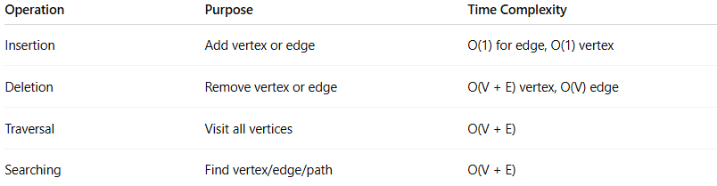
Operation | Purpose | Time Complexity
Insertion | Add vertex or edge | O(1) for edge, O(1) vertex
Deletion | Remove vertex or edge | O(V + E) vertex, O(V) edge
Traversal | Visit all vertices | O(V + E)
Searching | Find vertex/edge/path | O(V + E)

Example Graph in C (Adjacency List)
# Source: AI Source: Provided by: [Data Path: Persons Table -> ID Column: 1, Name_En Column: Motasem Essam] -> From: [Chatgpt (GPT‑5 Mini)] on [12/10/2025]
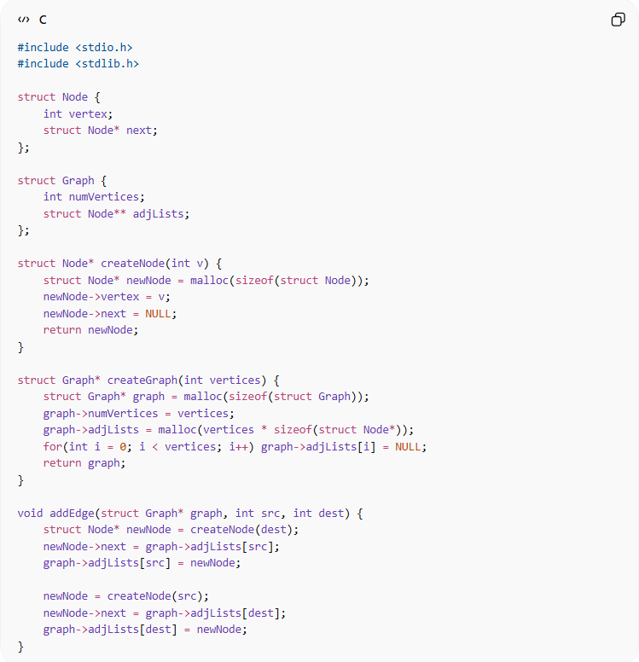
#include <stdio.h>
#include <stdlib.h>

struct Node {
int vertex;
struct Node* next;
};

struct Graph {
int numVertices;
struct Node** adjLists;
};

struct Node* createNode(int v) {
struct Node* newNode = malloc(sizeof(struct Node));
newNode->vertex = v;
newNode->next = NULL;
return newNode;
}

struct Graph* createGraph(int vertices) {
struct Graph* graph = malloc(sizeof(struct Graph));
graph->numVertices = vertices;
graph->adjLists = malloc(vertices * sizeof(struct Node*));
for(int i = 0; i < vertices; i++) graph->adjLists[i] = NULL;
return graph;
}

void addEdge(struct Graph* graph, int src, int dest) {
struct Node* newNode = createNode(dest);
newNode->next = graph->adjLists[src];
graph->adjLists[src] = newNode;

newNode = createNode(src);
newNode->next = graph->adjLists[dest];
graph->adjLists[dest] = newNode;
}

Real-World Examples
# Source: AI Source: Provided by: [Data Path: Persons Table -> ID Column: 1, Name_En Column: Motasem Essam] -> From: [Chatgpt (GPT‑5 Mini)] on [12/10/2025]
- Social networks (friends/followers)
- Road networks (cities connected by roads)
- Internet routing (servers connected by links)
- Airline connections (airports and flights)

Advantages
# Source: AI Source: Provided by: [Data Path: Persons Table -> ID Column: 1, Name_En Column: Motasem Essam] -> From: [Chatgpt (GPT‑5 Mini)] on [12/10/2025]
- Can represent complex relationships
- Supports dynamic connections
- Efficient for pathfinding and connectivity analysis

Disadvantages
# Source: AI Source: Provided by: [Data Path: Persons Table -> ID Column: 1, Name_En Column: Motasem Essam] -> From: [Chatgpt (GPT‑5 Mini)] on [12/10/2025]
- Traversal and search can be time-consuming for large/dense graphs
- May consume large memory for adjacency matrix

